# **Information available from Letwell Parish Council under the Agreed model publication scheme – May 2025**

|  |  |  |
| --- | --- | --- |
| Information to be published | How the information can be obtained | Cost |
| Class1 - Who we are and what we do  (Organisational information, structures, locations and contacts)    This will be current information only    N.B. Councils should already be publishing as much information as possible about how they can be contacted. | (hard copy and/or website) |  |
| Who’s who on the Council and its Committees | Website  Hard copy – contact  Parish Clerk | Free  10p/sheet |
| Contact details for Parish Clerk and Council members (named contacts where possible with telephone number and email address (if used)) | Website  Newsletter  Parish Notice Board Hard copy – contact  Parish Clerk | Free  Free  Free  10p/sheet |
| Location of main Council office and accessibility details | Website  Parish Notice Board Hard copy – contact  Parish Clerk | Free  Free  10p/sheet |
| Staffing structure | Not applicable – Just Clerk | Not applicable – Just Clerk |
|  |  |  |

|  |  |  |
| --- | --- | --- |
| Class 2 – What we spend and how we spend it  (Financial information relating to projected and actual income and expenditure, procurement, contracts and financial audit)    Current and previous financial year as a minimum | (hard copy and/or website) |  |
| Annual return form and report by auditor | Hard copy – contact Parish Clerk | 10p/sheet |
| Finalised budget | Hard copy – contact Parish Clerk | 10p/sheet |
| Precept | Website  Hard copy – contact  Parish Clerk | Free  10p/sheet |
| Borrowing Approval letter | Not applicable | Not applicable |
| Standing Orders and Financial Regulations | Website  Hard copy – contact  Parish Clerk | Free  10p/sheet |
| Grants given and received | Hard copy – contact Parish Clerk | Free |
| List of current contracts awarded and value of contract | Hard copy – contact Parish Clerk | 10p/sheet |
| Members’ allowances and expenses | Hard copy – contact Parish Clerk | 10p/sheet |
|  |  |  |
| Class 3 – What our priorities are and how we are doing  (Strategies and plans, performance indicators, audits, inspections and reviews) | (hard copy or website) |  |
| Parish Plan (current and previous year as a minimum) | n/a | n/a |
| Annual Report to Parish or Community Meeting (current and previous year as a minimum) | Hard copy – contact Parish Clerk | 10p/sheet |
| Quality status | Not applicable | Not applicable |

|  |  |  |
| --- | --- | --- |
| Local charters drawn up in accordance with DCLG guidelines | Not applicable | Not applicable |
|  |  |  |
| Class 4 – How we make decisions  (Decision making processes and records of decisions)    Current and previous council year as a minimum | (hard copy or website) |  |
| Timetable of Council meetings | Website  Parish Notice Board Hard copy – contact  Parish Clerk | Free  Free  10p/sheet |
| Agendas of meetings (as above) | Website  Hard copy – contact  Parish Clerk | Free  10p/sheet |
| Minutes of meetings (as above) – nb this will exclude information that is properly regarded as private to the meeting. | Website  Hard copy – contact  Parish Clerk | Free  10p/sheet |
| Reports presented to council meetings - nb this will exclude information that is properly regarded as private to the meeting. | Website  Hard copy – contact  Parish Clerk | Free  10p/sheet |
| Responses to consultation papers | Hard copy – contact Parish Clerk | 10p/sheet |
| Responses to planning applications | Website  Hard copy – contact  Parish Clerk | Free  10p/sheet |
| Bye-laws | Not applicable | Not applicable |
|  |  |  |
| Class 5 – Our policies and procedures  (Current written protocols, policies and procedures for delivering our services and responsibilities) | Copies of all these documents can be obtained: Website | Free |

|  |  |  |
| --- | --- | --- |
| Current information only | Hard copy – contact Parish Clerk | 10p/sheet |
| Policies and procedures for the conduct of council business:  Standing orders  Financial Regulations  Delegated authority in respect of officers  Code of Conduct  Policy statements | Copies of all these documents can be obtained:  Website  Hard copy – contact  Parish Clerk | Free  10p/sheet |
| Policies and procedures for the provision of services and about the employment of staff:  Internal policies relating to the delivery of services  Equality and diversity policy  Health and safety policy  Recruitment policies (including current vacancies)  Policies and procedures for handling requests for information  Complaints procedures (including those covering requests for information and operating the publication scheme) | Copies of all these documents can be  obtained    Website  Hard copy – contact  Parish Clerk | Free  10p/sheet |
| Information security policy | Not applicable | Not applicable |
| Records management policies (records retention, destruction and archive) | Website  Hard copy – contact  Parish Clerk | Free  10p/sheet |
| Data protection policies | Website  Hard copy – contact  Parish Clerk | Free  10p/sheet |
| Schedule of charges (for the publication of information) | Website  Hard copy – contact  Parish Clerk | Free  10p/sheet |
|  |  |  |
| Class 6 – Lists and Registers    Currently maintained lists and registers only | (hard copy or website; some information may only be available by inspection) |  |

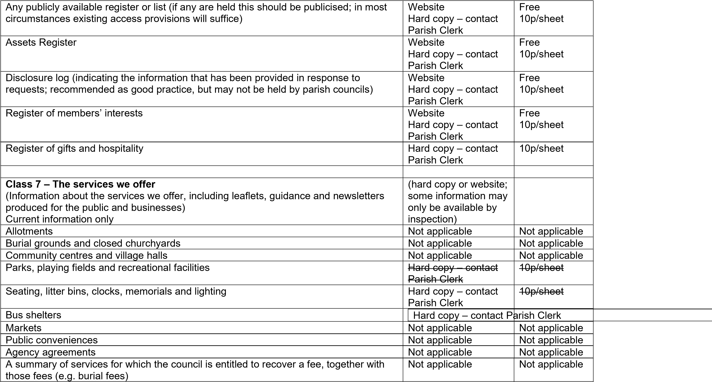

|  |  |  |
| --- | --- | --- |
|  |  |  |
| Additional Information  This will provide Councils with the opportunity to publish information that is not itemised in the lists above |  |  |
| None |  |  |

Contact details:

Parish Clerk and Responsible Financial Officer

Letwell Parish Council 07758822654

[clerk@letwell-pc.gov.uk](mailto:clerk@letwell-pc.gov.uk)

SCHEDULE OF CHARGES

This describes how the charges have been arrived at and published as part of the guide.

|  |  |  |
| --- | --- | --- |
| TYPE OF CHARGE | DESCRIPTION | BASIS OF CHARGE |
| Disbursement cost | Photocopying @ 10p per sheet (black & white) | Actual cost * |
|  | Photocopying @ 20p per sheet (colour) | Actual cost* |
|  |  |  |
|  | Postage | Actual cost of Royal Mail standard 2nd class |
|  |  |  |
| Statutory Fee | Not applicable | In accordance with the relevant legislation (quote the actual statute) |
|  |  |  |
| Other | Not applicable |  |

* the actual cost incurred by the public authority